Parts and Accessory Providers
FOR INFORMATIONAL PURPOSES ONLY
Based on form, fit and function of a 2014 Chevy RT 190-P on a 2013 Chevy 3500 Express Chassis. Some items may fit/be used on different models. Check before ordering.
Updated 3-31-2019
A/C Shroud Servicing/Repair Tools and Materiels Listing (Multiple Items)

1. Muzata Heavy Duty Blind Rivet Nut Kit Set, Riveter Tool, Rivet Nut Gun, Thread Hand Riveter, Rivet Gun, Riveting Tools with 100PCS Metric Rivet Nuts Included M3 M4 M5 M6 M8, available through Amazon
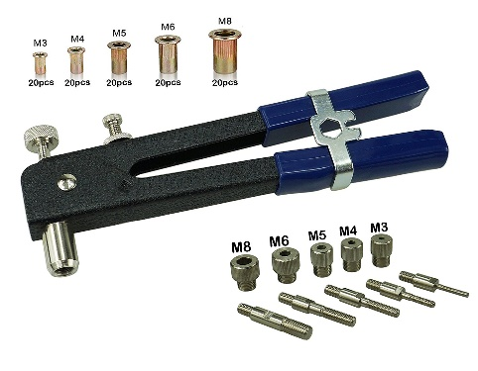

2. Shroud Nuts,Stainless Steel 304 Rivet Nut Rivnut Insert Nutsert - #10-32 UNC Nuts, available through Amazon

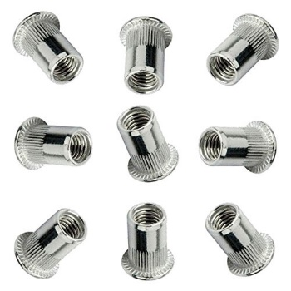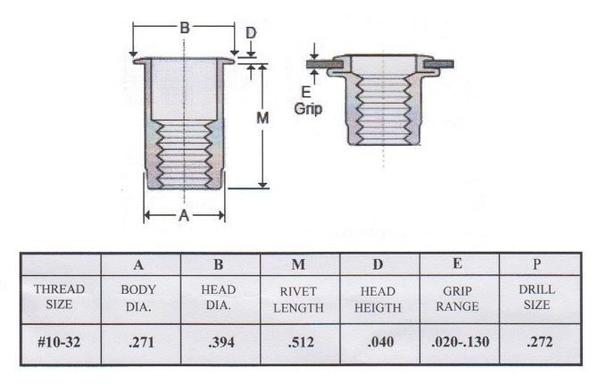

3. Stainless Steel Square Drive Pan Head Machine Screw #10-32 x 1"

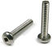

Air deflector, aka Bug Shield Genuine GM part number 12498604, Hood Air Deflector, available through Amazon see https://www.amazon.com/gp/product/B000QINVJ8/ref=oh_aui_search_asin_title?ie=UTF8&psc=1&fbclid=IwAR08ZQKuAwv_gFWguf6GwHzcI8u7FqhebcWM7xAtxS_BlTT_wXrH6KTQVjE
Thanks to Dee Ranger for providing info.
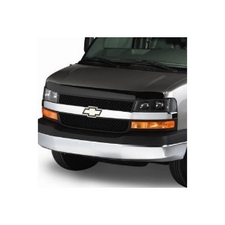
Cabinet Push Style Locks, Available through multiple sources at Amazon, see https://www.amazon.com/gp/aw/d/B06Y2R3CNZ/ref=ya_aw_od_pi...

Anti-Fatigue Mat, Venture 4 x 8 Foot Grey Roll Up Mat, for use in covering the entire plastic tub of your rig. Other models are available this one is just an example.
https://www.modells.com/venture-4-x-8-foot-grey-roll-up-mat/200076589.html
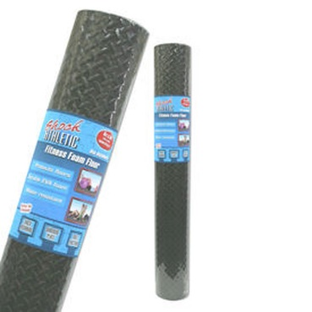

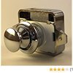

Cabinet Latches, Available through One Source RV on Amazon at

https://www.amazon.com/gp/product/B0006I0NU8/ref=ppx_yo_dt_b_asin_title_o00_s00?ie=UTF8&psc=1&fbclid=IwAR15UUqmIxf7ElIfPor_m2wR1tZTvvoABQ0myomUzJuNzXnF6uFKxfc8vuU
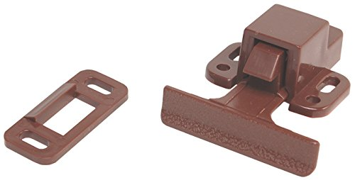

Ceiling Panel Buttons, Available at Fastenal, #6 1 inch screws

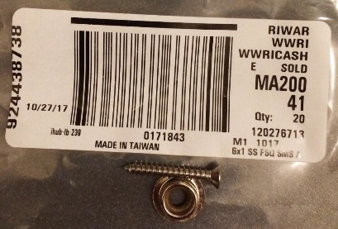

Clearance Lamps, AutoZone

- Blazer Amber Part # B485A, Price: $4.99.
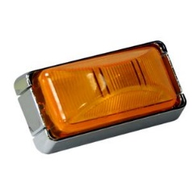

2. Blazer Red Part # B485R, Price $4.99
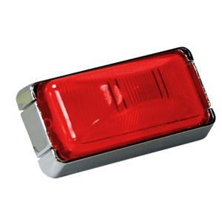
Coupler, Rubber, Sewer, Fernco, Part # 1056-33. Available locally at big box hardware stores.

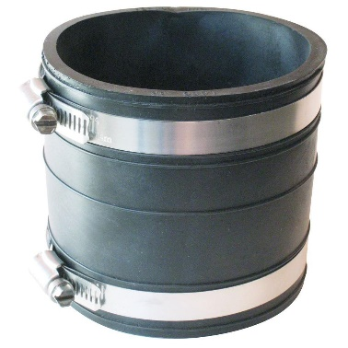

Cool-Cat Potential Replacement Units, these units are provided as potential replacements for the Cool-Cat. It is your responsibility to ensure form, fit, and function. Thanks Nicholas R.
LG LW8016ER 8,000 BTU 115V Window-Mounted AIR Conditioner (no heat) with Remote Control......Product Dimensions 19.6(D) x 19.4(W) x 12.4(H) inches
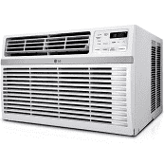
LG 7,500 BTU 115V Window-Mounted AIR Conditioner with 3,850 BTU Supplemental Heat Function....20.9 x 18.4 x 13.9 inches
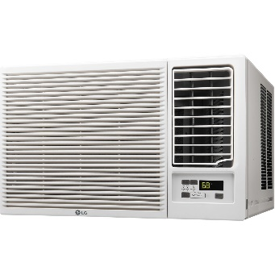
Dump Hose (Replacement), Clean Dump, 360.798.2437, http://www.cleandump.com

Engine Belts (2013 Chevy Express 3500)

GM #’s Serpentine Belt GM # 12637204
Advance Auto - Carquest # 5060930

GM #’s A/C Belt GM # 12624100
Advance Auto - Carquest # E040357

Belt Routing Diagram
Floor Mats, Loyds Custom Floor Mats, https://www.lloydmatsstore.com/rubbertite-floor-mats
Frig Fans, - Inside and Outside
Can be purchased as full kits from RV Cooling Unit Warehouse @ https://rvcoolingunit.com/Default.aspx
Condenser Fan (1) Kit w/thermostat and wiring Harness https://rvcoolingunit.com/Condenser-Fan-1-Kit-wthermostat-and-wiring-Harness-P5652851.aspx $34.95
Dometic Evaporator Fan Greater inside Cooling Customer Deluxe w/Grill https://rvcoolingunit.com/Dometic-Evaporator-Fan-Greater-inside-Cooling-Customer-Deluxe-wGrill-P3239952.aspx $24.95
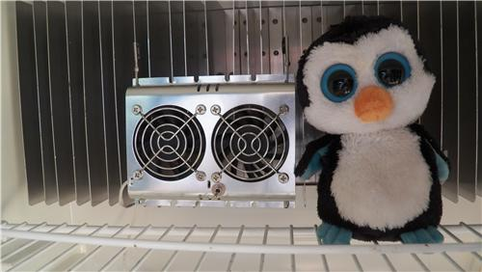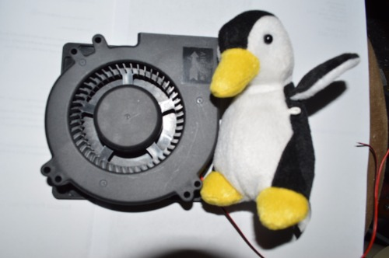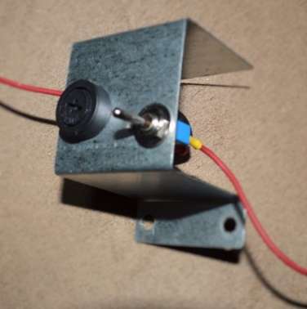
Installed pictures available upon request of both items. Just PM me.
Galley Faucet, Dometic Part Number 3313070.001
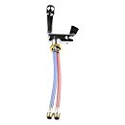
Galley Faucet, Patrick Distribution Single Handle RV Kitchen Faucet with Pull Down Spout # 277-000101. Can be purchased through Etrailer has a great article and video about placement kitchen faucets as well at https://www.etrailer.com/question-216912.html . However it is not foldable…
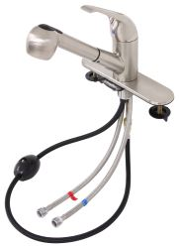

Ground Effects (Fiberglass Trim) Repair. Detailed repair instructions and pictures can be obtained at https://l.facebook.com/l.php?u=https%3A%2F%2Fsites.google.com%2Fsite%2Froadtrekersite%2Fmodifications%2Fground-effects-repair&h=AT3IU9vprO2DNVa15pgdcv2Qft9wTpZWBxqUyJgRY4D9wRwXtK3bQvVv4Tq2P06yuQI4Xt1mxWmdSNHO4V5tQVJNnnAV7m7pZCxLZICKysLJgzz-s3MC4IW1Kr2Bjby1y98 . This information was kindly provided by David Parker
Required parts for repair:
Clips 06002500 go behind the molding up from the bottom. You can see the clips, if you open a door and look up from the bottom. Should be 3 of them.
Washers 14013395, you cannot see. They go behind the rubber trim and actually secure the molding with the screws to the outside of the door.
Both of these parts can be obtained from your local dealer or Mr. Dan Neeley. Of Dan Neeley RV Service dnrvservice@icloud.com .
Hinges for External Storage Compartments Moore Industrial Hardware, 777 Circle Freeway Dr., Cincinnati, OH 45246-1298, 800-543—1677 or 513-874-07900,info@mooreindhardware.com
http://catalog.mooreindhardware.com/keyword/all-categories/continuous-hinges-plastic?&plpver=1001&keyword=continuous+hinges%2c+plastic&key=product&keycateg=100&keyprod=3001510&SchType=2&refer=http%3a%2f%2fwww.mooreindhardware.com
LED Replacement Bulbs. Direct plug and Play https://www.amazon.com/gp/product/B07BB946CK/ref=oh_aui_search_asin_title?ie=UTF8&psc=1

Macerator - SHURFLO (3200-001) 12V Macerator Pump, available via Amazon
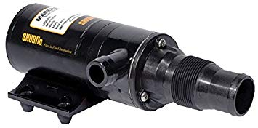
Macerator Replacement Hose – Clean Dump, 20' Macerator Hose & Valve, Item 88-8656 | MFR# CDHV-20, available on line from multiple sources and manufacturers.
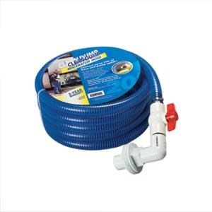
Patio Light *12 VOLT 18 LED PORCH LIGHT OVAL AMBER RV BLACK EXTERIOR Ebay Aug 2017 ( 253043583502 ) Sold by cmlsurpluscindy
Ramps, Wooden, You have to make them yourself but they are provided courtesy of a member of the blog. Each one is made with one 2”x10”x8’ board. The cut lengths are multiples of 9”. That turns out to be 36”, 27”, 18” and 9”. That totals to 90” giving a leftover board piece of about 6”. Bevel the pieces at 45° angle at 3/4 of an inch to allow the tires an easier time to roll up. Use the leftover piece at the end unbeveled and raise about 1 inch higher than the top piece (didn’t want to make it higher so it won’t impede the tire rolling to the top step). Use 2.5 inch decking screws to hold it together and seal with Thompson’s Waterseal. Use and manufacture at YOUR OWN RISK. YOUR RESULTS MAY VARY. BTW Thanks David E. B.
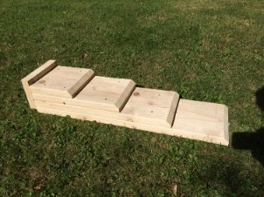
Seat Covers, Neoprene (Custom Made)
Saddleman, Patrick Crofoot, 973-812-8820, patrickc@aii-usa.com , www.saddleman.com
Sink, Flange nut Replacement, available at plumbing supply stores.
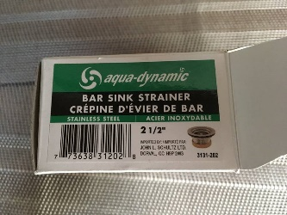
Water Pump, Shur-Flo, Part # 4008-101-E65
Window, Rear Replacement, applicable to some RT vehicles. Contact TAP Plastics at 1-209-937-9300 and order a Lexan/polycarbonate window replacement cut to size. Check your needed size. This drawing/measurements were for a 2002 Chevy RT 190-P. Your results may vary.
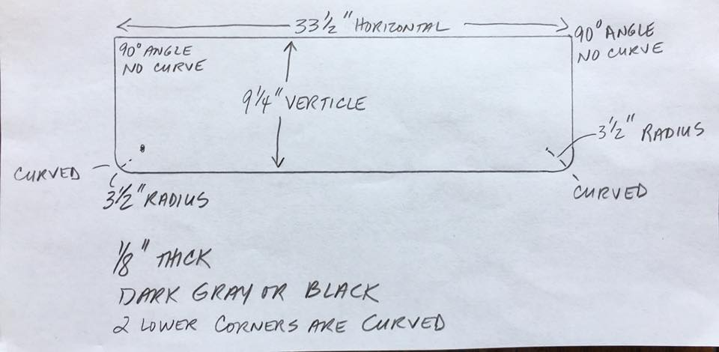
Window Screens, Multiple sources: www.skeeterbeather.com and http://www.skreenz.com/ .

